**Moulik Tammana**

**Q5. Create a simple LAN setup with two Linux machines connected via a switch.**

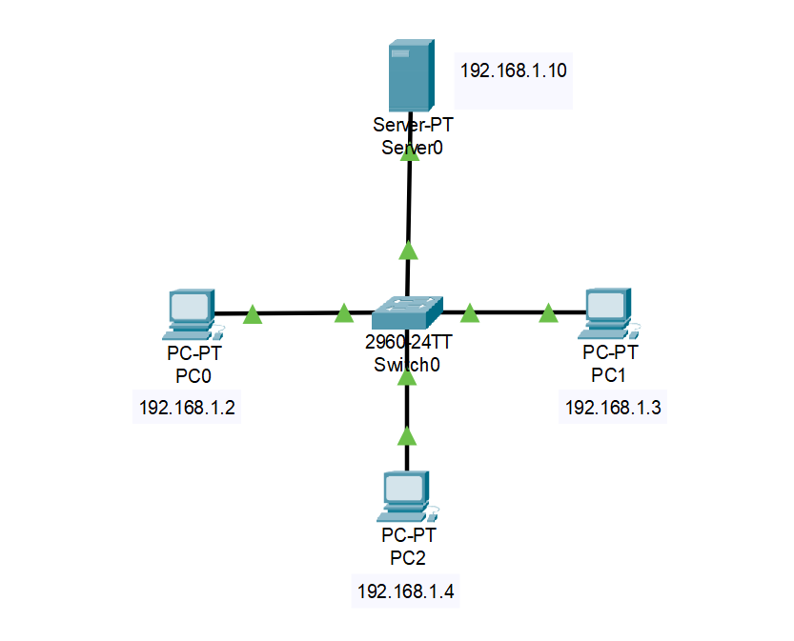

Using the ping command to check the connection between the end devices: 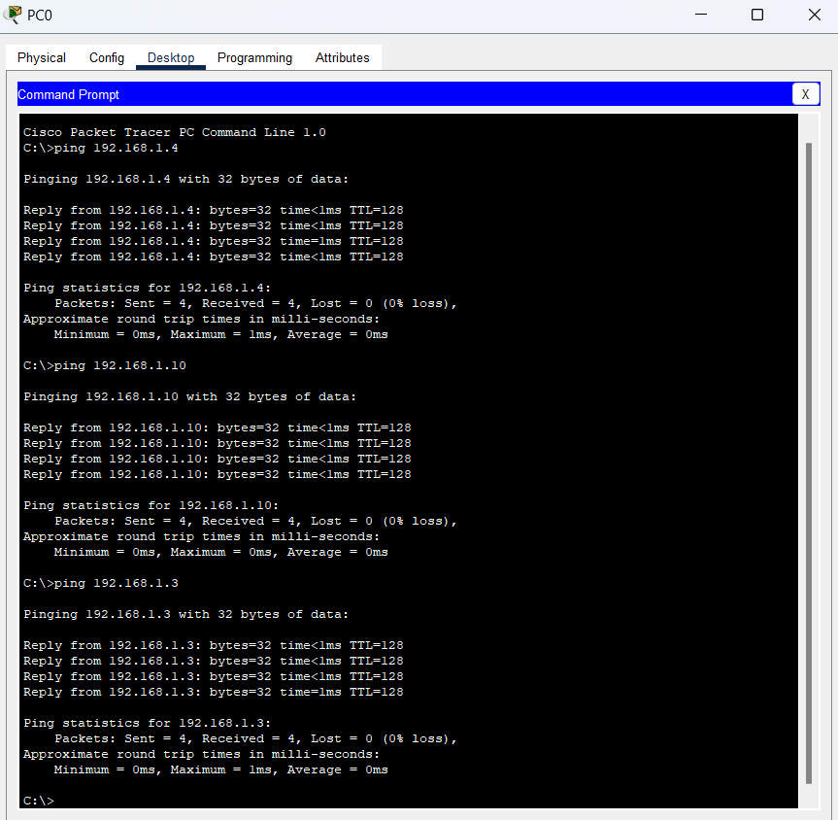

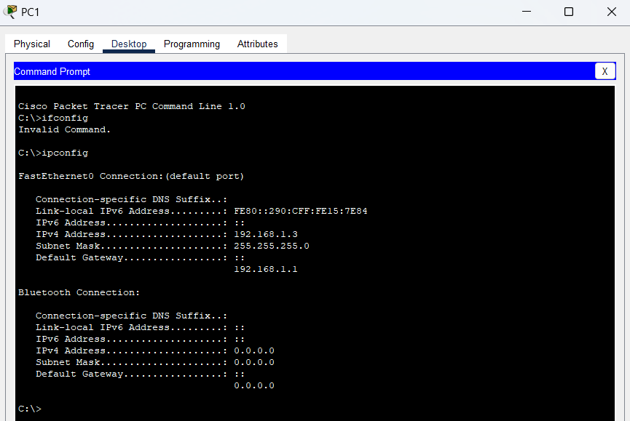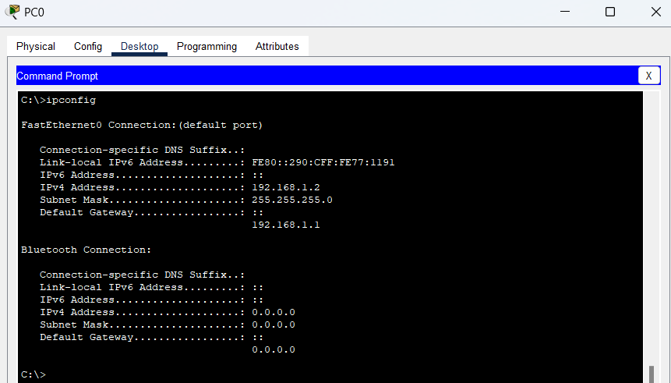

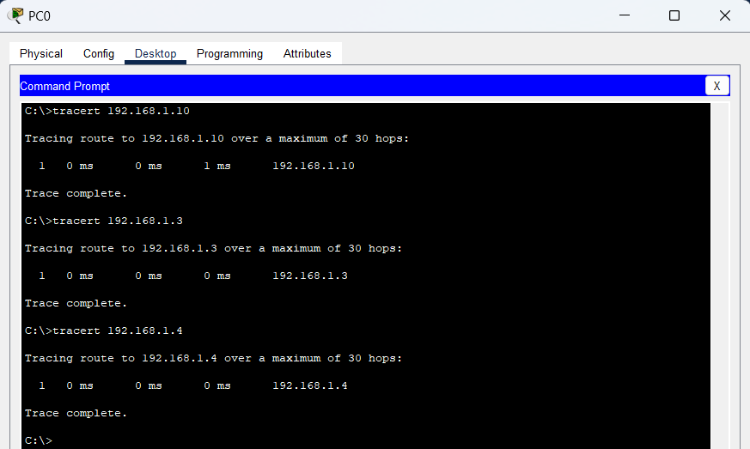

**Q6. Research the Linux kernel's handling of Ethernet devices and network interfaces. Write a short report on how the Linux kernel supports Ethernet communication (referencing kernel.org documentation).**

The Linux kernel manages Ethernet devices and network interfaces through its network stack, enabling seamless communication between software and hardware. Each network interface (such as eth0 for wired Ethernet) is treated as a device file in /sys/class/net/, and the kernel interacts with them via network drivers. These drivers act as intermediaries between Ethernet hardware and the kernel’s networking subsystems.

When data is transmitted, the kernel processes it through multiple layers. At the Network Interface Layer, drivers manage physical transmission and reception of packets. The Internet Layer (IP) determines routing, while the Transport Layer (TCP/UDP) ensures reliable or fast delivery, depending on the protocol used. The kernel optimizes performance with offloading techniques such as Generic Receive Offload (GRO) and TCP Segmentation Offload (TSO).

Additionally, Linux supports virtual network interfaces like VLANs, bridges, and tunnels, which are crucial for advanced networking configurations. Users can configure interfaces with tools like ip link, ifconfig, and ethtool to set IP addresses, adjust MAC addresses, or enable/disable interfaces. Security and traffic control are managed using iptables for packet filtering and traffic shaping.

The Linux kernel’s scalable and efficient networking framework makes it ideal for various applications, from personal systems to enterprise and cloud environments.